*“*Food for friends*”*:

New way for people get friends through social net work application and food

**THESIS**

**Submitted in Partial Fulfillment of**

**the Requirements for**

**the Degree of**

MASTER OF SCIENCE (Integrated Digital Media)

at the

NEW YORK UNIVERSITY

TANDON SCHOOL OF ENGINEERING

By

Tianyu Ren

Spring 2016

## 

*“*Food for Friends*”*:

New way for people get friends through social net work application and food

**THESIS**

**Submitted in Partial Fulfillment of**

**the Requirements for**

**the Degree of**

MASTER OF SCIENCE (Integrated Digital Media)

at the

NEW YORK UNIVERSITY

TANDON SCHOOL OF ENGINEERING

By

Tianyu Ren

Spring 2016

Approved:

Adviser Signature

Date

Department Head Signature

Date

Copy No.

University ID#:

# Approved by the Guidance Committee:

Integrated Digital Media

Brian MacMillan, Project Advisor

Integrated Digital Media

NYU Polytechnic School of Engineering

Date

DeAngela Duff, Co-Director

Integrated Digital Media

NYU Polytechnic School of Engineering

Date

Karl Hohn, External Reviewer

Software Application Developer

Date

# Vita

Tianyu Ren was born in Beijing, People’s Republic of China, in 1990. He attended school at the Hangzhou Dianzi University, where he studied Printing Engineering and received a bachelor's degree in Engineering in 2012. In 2013 he began a master’s degree in Integrated Digital Media at New York University, where he learned web design, multi-media design and digital media. The artistic atmosphere in New York attracts him. After

graduation, he intends to pursue a career in commercial photography and videography.

# Abstract

*“*Food for friends*”*:

A new way for people get friends through social net work application and food

**by**

**Tianyu Ren**

**Advisor: Prof. Brian MacMillan, MS**

**Submitted in Partial Fulfillment of the Requirements for**

**the Degree of Master of Science (Integrated Digital Media)**

**May 2016**

**Food for Friends** is an application to help people who we are new in a new place or travelers to have new friends. At the same time, through this application people can get reasonable price food and have an unforgettable travel experience and memory. Through this platform, users can have different experiences than provide by other travel or food guide applications or any other social network applications. People can get face to face connections with other people.

Keywords: food, friends, application, new travel experience, social network

# Table of Contents

Approved by the Guidance Committee: ii

Vita iii

ABSTRACT iv

Table of Contents v

List of Figures vi

Background 1

Introduction 1

Research 1

Statement of Purpose 2

Background 2

Target and Audience 3

Research Overview 3

Methods and Techniques 4

Technology Overview 4

Visual: 4

Design 4

Development 10

Market 11

Outcomes and Conclusions 11

What Worked 11

What Did Not Work 11

Options For Expansion 11

Conclusions 11

vite 12

# List of Figures

**Figure 2**: home page 6

**Figure 3**: recommend page 6

**Figure 4**: restaurant information page 7

**Figure 5**: City page 7

**Figure 6**: Restaurant page 8

**Figure 7**: personal information page 8

**Figure 8**: message page 9

**Figure 9**: food story page 9

**Figure 10**: food story page 2 10

**Figure 11**: favorite page 10

**Figure 12**: create group page 11

# Background

## Introduction and Statement of Purpose

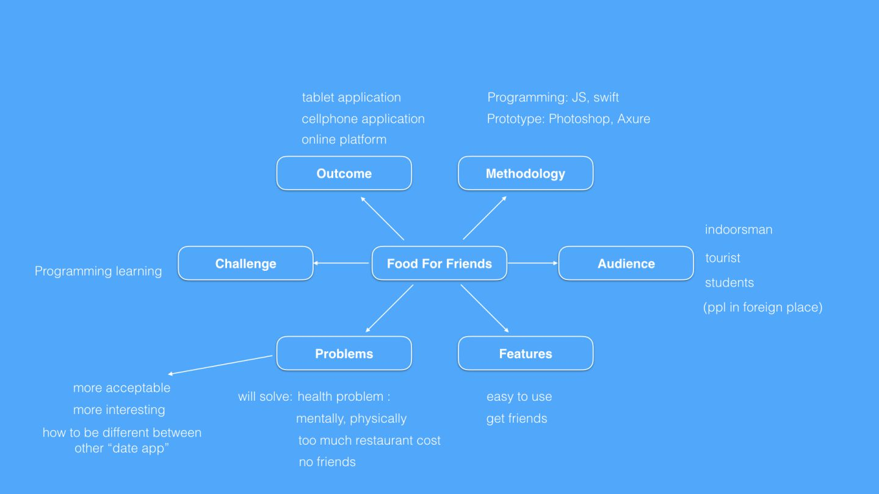

图 1 Brain storm Mind map.

With globalization increasing rapidly, people from different cultures and different countries are mixing a lot, through travel and immigration. Millions people are living in NYC, and there are so many different cultures. [However, I think this advantage was not good use.] Humans are curious about different cultures but most of them don’t have opportunities to get a different culture friend. And also there are many new people come to a new place every day. How to help them go inside to the new cultures (new environment) is a big problem. [Food for Friends is an application that hopes to overcome this problem by allowing people new to a city to meet while eating.]

There are lots of social network mobile applications in the market and there are also many food rating platforms now too. The market for restaurant and social network users is growing so fast, and lots of new apps are coming out every day. When people make friends with others using applications, actually they are using their personality attributes to build connections with others, based on habit and interest. I pick one of the most important and specific conceptions from people’s interest and use it to build a new way to help people to connect with each other and have fun.

By using “Food For Friends”, people who are in a strange place or tourists are able to get to know new people and make new friends when they are having delicious food. There are already a few information-sharing mobile applications and websites trying to provide useful travel information for travelers, such as Yelp and Expedia. However, they ignore the importance of connections between people, and people in these kinds of platforms just can see the tips and information that people written, but sometimes these writings are not current so they may be useless. This makes their user experience bad. To give a better user experience for people and help people get friends when they are in a new place, “Food for Friends” gives people useful and latest information, and help more people in their trips.

“Food For Friends” is a web based information-sharing mobile application for travelers and people in new places who are without friends and feeling lonely, which aims to be the best trip-guide for travelers *and* a good social network platform. The main idea of the “Food for friends” is about four functions for users: restaurant recommendations, travel guide, friend making and socializing.

There are some apps in the app store right now that have similar features to Food for Friends. So how is “Food for Friends” different?

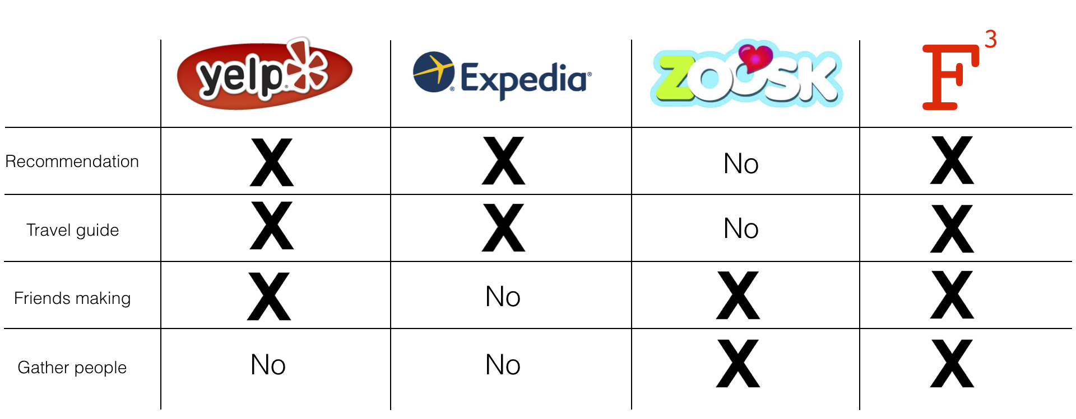

Figure : Food for Friends has four functions: restaurant recommendation, travel guide, friends making and gather people

“Food for Friends” is an application that combine some useful and important features from other applications.

It is well known that Yelp and Expedia are very useful recommendation applications, they can provide lots of useful information and tips about restaurants and places, and people even can know who wrote the reviews through the Facebook account link. Most of the time these kind of applications can help us to find what we want. However, when people are outside alone, what they most want is a person to share happiness and wonderful experiences with them. Therefore, there is an another function in “Food for Friends” that helps people find other people and get them together by GPS, people who have the same interest on food and habits could get together and have fun together. The inspiration of this function is from date applications such as “Zoosk”, people can build themselves’ groups and have fun together with the group members.

## Target and Audience

“Food for Friends” focuses on travelers and other people, for example immigrants, who come to a strange place and want to have some friends. At the same time, “Food for Friends” also wants to help people have nice and delicious food at a reasonable price with a friendly and unforgettable experience and memory. It can also be a useful food guide for foodies.

# Methods and Techniques

## Design

Why I choose the iOS platform as the first choice?

I have chosen to develop the first version of Food for Friends in iOS for Apple phones iOS 7.0+. The reason why I choose iPhone users as the main audiences is because the advertisement income for iOS developer is more than Android developer (see figure 2). At the same time, unlike the Apple store, which has very strict auditing system procedures, Android apps have huge security risks particularly in China, Android users’ personal information can’t be well protected.

1. Security problems of Android

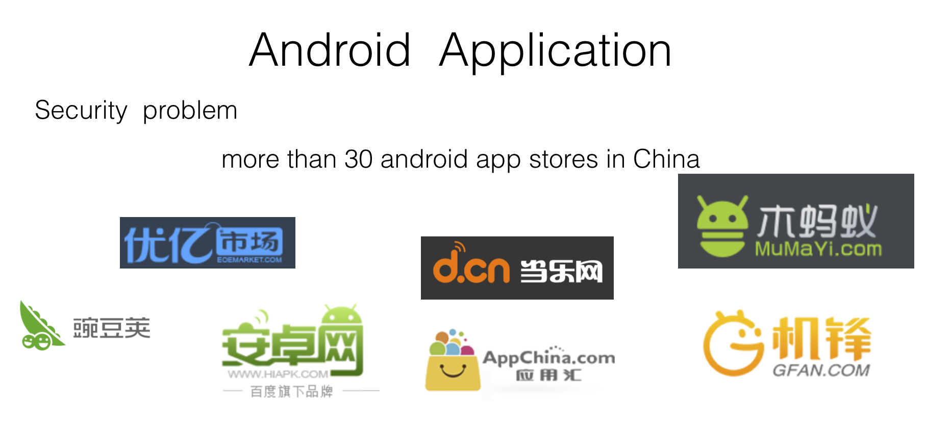

Figure 3: The logos of Android app stores in China

Food for Friends is an application only for iOS system. iOS system is much safer than Android system although Android system have much more market than iOS system. In China, there are more than 30 Android app stores, and most of them are not such formal as the Google app store. There are so many hacker apps in these stores and it should be a big security risk for users’ personal information. Therefore, because there will be a lot of personal data on the “Food for Friends”, iOS app store should be the best platform for it.

1. Advertising Income

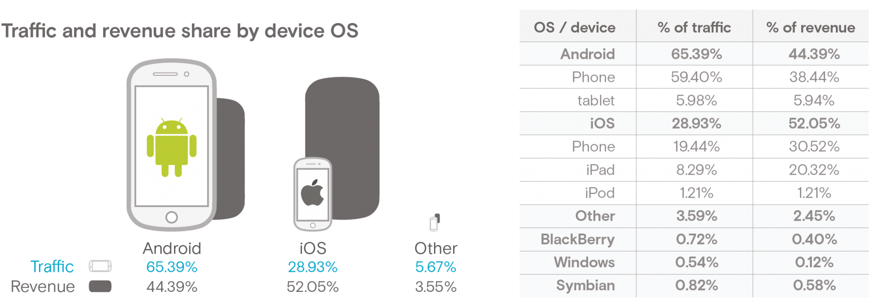

Figure 2: iOS vs Android advertising income in 2015Q3

There is another reason for using the iOS system: Although the iOS market is smaller than the Android market in the whole smartphone market (figure 2), the advertising income for iOS developers is still higher than for Android developers. For “Food for Friends”, advertising income from the restaurants would be important part of the whole income.

UI design as seen in **Figure 1**

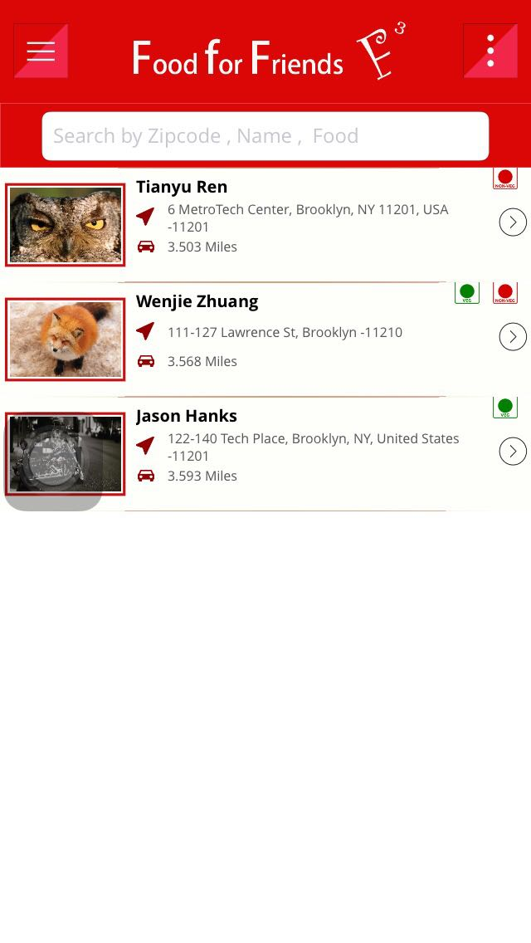

1. Show a list of users who are near by

2. Show the address of users who are near by

3. Show if users are vegetarians

4. Search users or restaurant in the data end

5. Left top button is the main menu button

6. Right top button is the map button could show positions of users who are near by on map

图 2 Home page

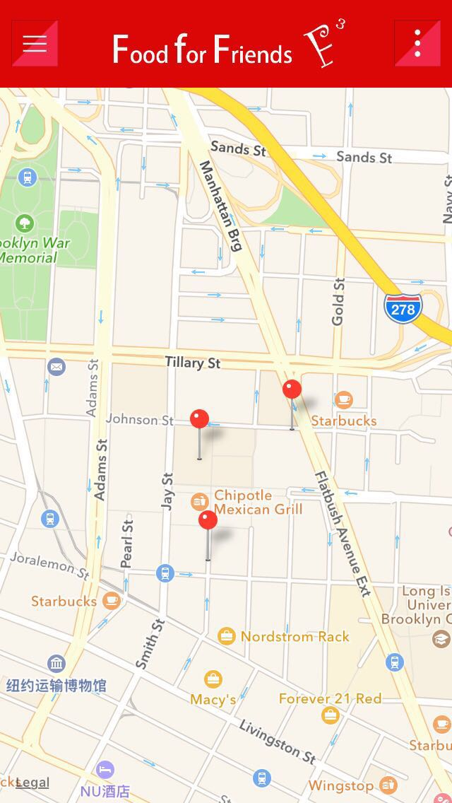

1. Show the positions of users who are near by on map

2. Left top button is the main menu button

3. Right top button is the button back to home page

图 3 Map page

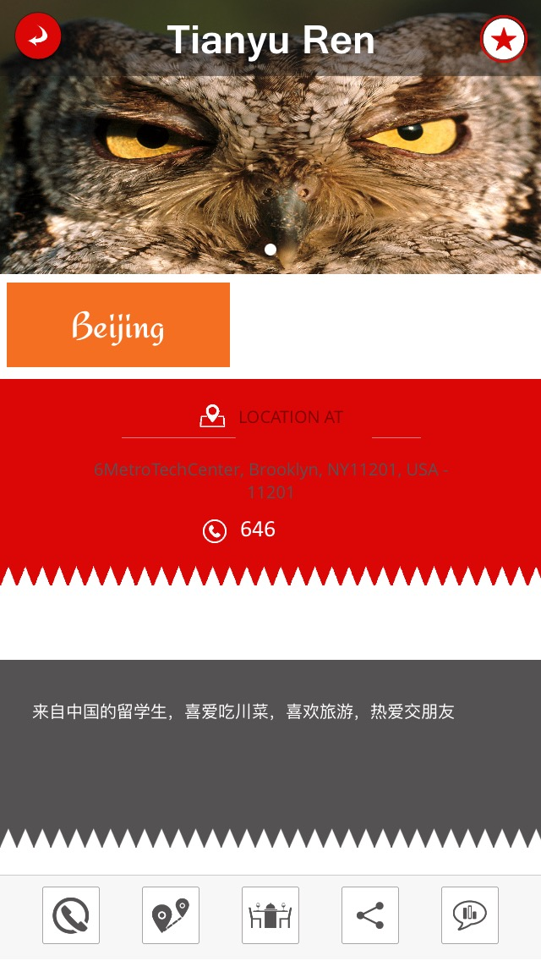

1. Show the location

2. Show the phone number

3. Show the favorite food of the user

4. Show the personal detail: age, hometown, interests, and personal intro

5. The bottom buttons: call button, map button, data/group/dinner invite button, social media button, SMS message button

6. The right top button is the friends button

图 4 Personal information page

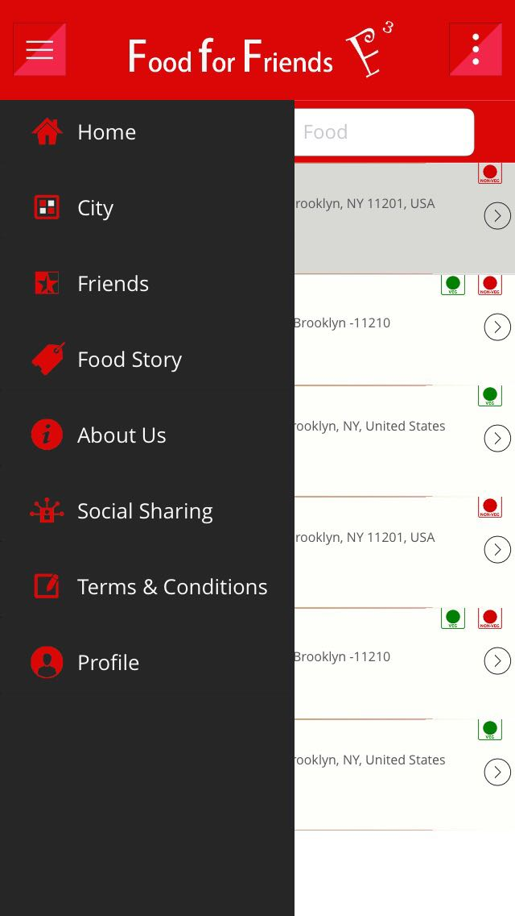

1. Main menu

2. Home button will take users to figure 2

图 5 Main menu

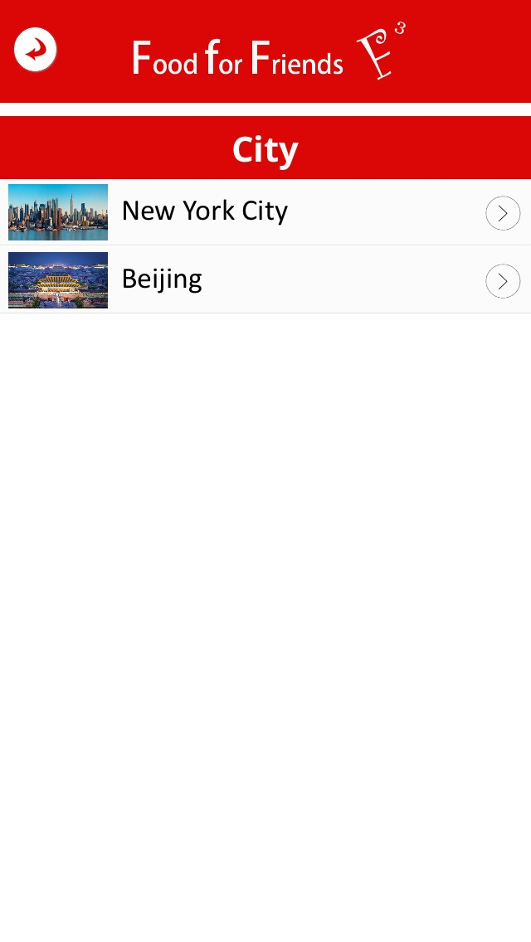

1. Left top button is back button. It takes user to the previous page

2. Different cities options

图 6 City page

1. Left top button is back button and takes user to previous page

2. Shows a list of restaurants

3. Shows if users are vegetarians

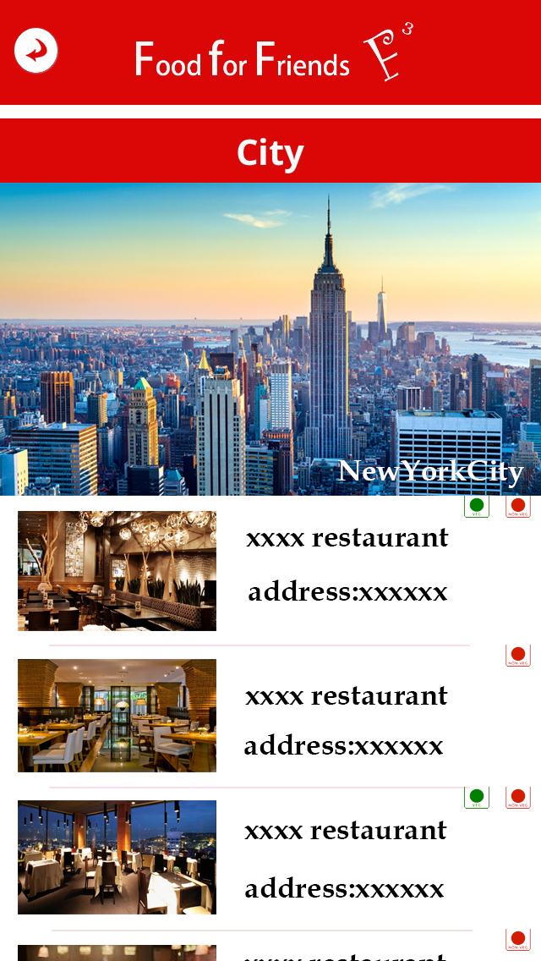

图 7 City page 2

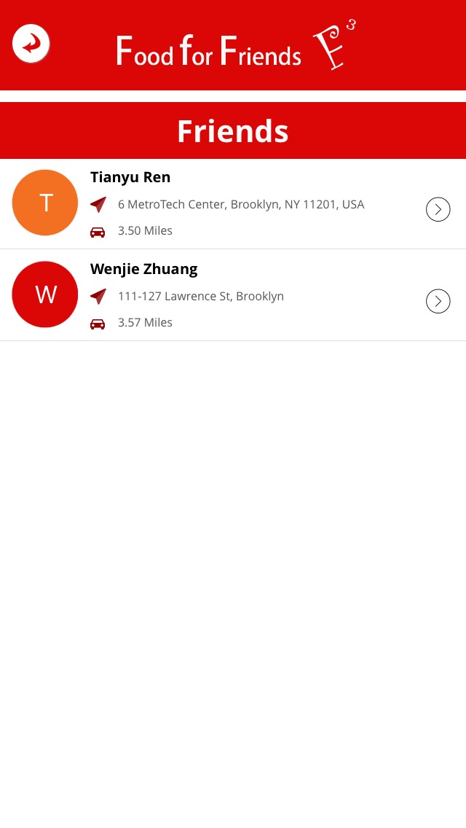

1. Left top button is back button and takes user to previous page

2. Shows the list of friends

3. Shows the friend’s position and distance from holder

图 8 Friends page

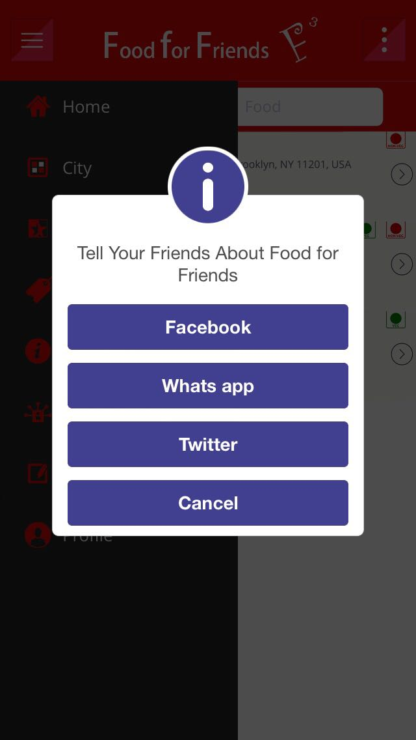

1. Can link to other social network account and share what you get in “Food for Friends”

图 9 Social share page

## 

## Development tools

Can you draw a system diagram

Data base:

DBMS: MySQL

C++

Front end: HTML & CSS javascript

Adobe Dreamweaver

Middleware: PHP

## Marketing

At the start, I want begin marketing “Food for Friends” among Chinese travelers and expatriates. At the same time, it’s would be comfortable for people using their Weibo and Wechat account to be authenticated using one of these applications. Weibo and Wechat the two most popular social network apps have millions of user so it would be easy for people to login.

In China, Weibo and Wechat have more than two hundred million users (as of 2015.12). The number of social media accounts is increasing rapidly too. How to effectively use the resource of the social media is a very important part of the Food for Friends marketing. Also Food for Friends will set up Weibo official account and Wechat official account to spread the influence of it. These official accounts will share the food stories which users wrote in the app, and at same time it will share special offers for people too.

From my research, I find that Chinese are more comfortable on sharing food with other people during the dinner, so this it would be much more acceptable for Chinese using this application than Americans, for example.

The business model for “Food for Friends” it based on the tourism Ads and restaurant ADs, people can see the ADs in the home page and restaurant. Restaurant and tourism guide could set Ads over there.

How Will You Keep Your Data Current?

* Could you create a business plan that features hiring staff to promote and research?
* Add screen shots of the restaurant maintenance function

**USER AGREEMENT []**

LICENSED APPLICATION END USER LICENSE AGREEMENT

The Products transacted through the Service are licensed, not sold, to You for use only under the terms of this license, unless a Product is accompanied by a separate license agreement, in which case the terms of that separate license agreement will govern, subject to Your prior acceptance of that separate license agreement. The licensor (“Application Provider”) reserves all rights not expressly granted to You. The Product that is subject to this license is referred to in this license as the “Licensed Application.”

a. Scope of License: This license granted to You for the Licensed Application by Application Provider is limited to a non-transferable license to use the Licensed Application on any iPhone or iPod touch that You own or control and as permitted by the Usage Rules set forth in Section 9.b. of the App Store Terms and Conditions (the “Usage Rules”). This license does not allow You to use the Licensed Application on any iPod touch or iPhone that You do not own or control, and You may not distribute or make the Licensed Application available over a network where it could be used by multiple devices at the same time. You may not rent, lease, lend, sell, redistribute or sublicense the Licensed Application. You may not copy (except as expressly permitted by this license and the Usage Rules), decompile, reverse engineer, disassemble, attempt to derive the source code of, modify, or create derivative works of the Licensed Application, any updates, or any part thereof (except as and only to the extent any foregoing restriction is prohibited by applicable law or to the extent as may be permitted by the licensing terms governing use of any open sourced components included with the Licensed Application). Any attempt to do so is a violation of the rights of the Application Provider and its licensors. If You breach this restriction, You may be subject to prosecution and damages. The terms of the license will govern any upgrades provided by Application Provider that replace and/or supplement the original Product, unless such upgrade is accompanied by a separate license in which case the terms of that license will govern.

b. Consent to Use of Data: You agree that Application Provider may collect and use technical data and related information, including but not limited to technical information about Your device, system and application software, and peripherals, that is gathered periodically to facilitate the provision of software updates, product support and other services to You (if any) related to the Licensed Application. Application Provider may use this information, as long as it is in a form that does not personally identify You, to improve its products or to provide services or technologies to You.

c. Termination. The license is effective until terminated by You or Application Provider. Your rights under this license will terminate automatically without notice from the Application Provider if You fail to comply with any term(s) of this license. Upon termination of the license, You shall cease all use of the Licensed Application, and destroy all copies, full or partial, of the Licensed Application.

d. Services; Third Party Materials. The Licensed Application may enable access to Application Provider’s and third party services and web sites (collectively and individually, "Services"). Use of the Services may require Internet access and that You accept additional terms of service.

You understand that by using any of the Services, You may encounter content that may be deemed offensive, indecent, or objectionable, which content may or may not be identified as having explicit language, and that the results of any search or entering of a particular URL may automatically and unintentionally generate links or references to objectionable material. Nevertheless, You agree to use the Services at Your sole risk and that the Application Provider shall not have any liability to You for content that may be found to be offensive, indecent, or objectionable.

Certain Services may display, include or make available content, data, information, applications or materials from third parties (“Third Party Materials”) or provide links to certain third party web sites. By using the Services, You acknowledge and agree that the Application Provider is not responsible for examining or evaluating the content, accuracy, completeness, timeliness, validity, copyright compliance, legality, decency, quality or any other aspect of such Third Party Materials or web sites. The Application Provider does not warrant or endorse and does not assume and will not have any liability or responsibility to You or any other person for any third-party Services, Third Party Materials or web sites, or for any other materials, products, or services of third parties. Third Party Materials and links to other web sites are provided solely as a convenience to You. Financial information displayed by any Services is for general informational purposes only and is not intended to be relied upon as investment advice. Before executing any securities transaction based upon information obtained through the Services, You should consult with a financial professional. Location data provided by any Services is for basic navigational purposes only and is not intended to be relied upon in situations where precise location information is needed or where erroneous, inaccurate or incomplete location data may lead to death, personal injury, property or environmental damage. Neither the Application Provider, nor any of its content providers, guarantees the availability, accuracy, completeness, reliability, or timeliness of stock information or location data displayed by any Services.

You agree that any Services contain proprietary content, information and material that is protected by applicable intellectual property and other laws, including but not limited to copyright, and that You will not use such proprietary content, information or materials in any way whatsoever except for permitted use of the Services. No portion of the Services may be reproduced in any form or by any means. You agree not to modify, rent, lease, loan, sell, distribute, or create derivative works based on the Services, in any manner, and You shall not exploit the Services in any unauthorized way whatsoever, including but not limited to, by trespass or burdening network capacity. You further agree not to use the Services in any manner to harass, abuse, stalk, threaten, defame or otherwise infringe or violate the rights of any other party, and that the Application Provider is not in any way responsible for any such use by You, nor for any harassing, threatening, defamatory, offensive or illegal messages or transmissions that You may receive as a result of using any of the Services.

In addition, third party Services and Third Party Materials that may be accessed from, displayed on or linked to from the iPhone or iPod touch are not available in all languages or in all countries. The Application Provider makes no representation that such Services and Materials are appropriate or available for use in any particular location. To the extent You choose to access such Services or Materials, You do so at Your own initiative and are responsible for compliance with any applicable laws, including but not limited to applicable local laws. The Application Provider, and its licensors, reserve the right to change, suspend, remove, or disable access to any Services at any time without notice. In no event will the Application Provider be liable for the removal of or disabling of access to any such Services. The Application Provider may also impose limits on the use of or access to certain Services, in any case and without notice or liability.

e. NO WARRANTY: YOU EXPRESSLY ACKNOWLEDGE AND AGREE THAT USE OF THE LICENSED APPLICATION IS AT YOUR SOLE RISK AND THAT THE ENTIRE RISK AS TO SATISFACTORY QUALITY, PERFORMANCE, ACCURACY AND EFFORT IS WITH YOU. TO THE MAXIMUM EXTENT PERMITTED BY APPLICABLE LAW, THE LICENSED APPLICATION AND ANY SERVICES PERFORMED OR PROVIDED BY THE LICENSED APPLICATION ("SERVICES") ARE PROVIDED "AS IS" AND “AS AVAILABLE”, WITH ALL FAULTS AND WITHOUT WARRANTY OF ANY KIND, AND APPLICATION PROVIDER HEREBY DISCLAIMS ALL WARRANTIES AND CONDITIONS WITH RESPECT TO THE LICENSED APPLICATION AND ANY SERVICES, EITHER EXPRESS, IMPLIED OR STATUTORY, INCLUDING, BUT NOT LIMITED TO, THE IMPLIED WARRANTIES AND/OR CONDITIONS OF MERCHANTABILITY, OF SATISFACTORY QUALITY, OF FITNESS FOR A PARTICULAR PURPOSE, OF ACCURACY, OF QUIET ENJOYMENT, AND NON-INFRINGEMENT OF THIRD PARTY RIGHTS. APPLICATION PROVIDER DOES NOT WARRANT AGAINST INTERFERENCE WITH YOUR ENJOYMENT OF THE LICENSED APPLICATION, THAT THE FUNCTIONS CONTAINED IN, OR SERVICES PERFORMED OR PROVIDED BY, THE LICENSED APPLICATION WILL MEET YOUR REQUIREMENTS, THAT THE OPERATION OF THE LICENSED APPLICATION OR SERVICES WILL BE UNINTERRUPTED OR ERROR-FREE, OR THAT DEFECTS IN THE LICENSED APPLICATION OR SERVICES WILL BE CORRECTED. NO ORAL OR WRITTEN INFORMATION OR ADVICE GIVEN BY APPLICATION PROVIDER OR ITS AUTHORIZED REPRESENTATIVE SHALL CREATE A WARRANTY. SHOULD THE LICENSED APPLICATION OR SERVICES PROVE DEFECTIVE, YOU ASSUME THE ENTIRE COST OF ALL NECESSARY SERVICING, REPAIR OR CORRECTION. SOME JURISDICTIONS DO NOT ALLOW THE EXCLUSION OF IMPLIED WARRANTIES OR LIMITATIONS ON APPLICABLE STATUTORY RIGHTS OF A CONSUMER, SO THE ABOVE EXCLUSION AND LIMITATIONS MAY NOT APPLY TO YOU.

f. Limitation of Liability. TO THE EXTENT NOT PROHIBITED BY LAW, IN NO EVENT SHALL APPLICATION PROVIDER BE LIABLE FOR PERSONAL INJURY, OR ANY INCIDENTAL, SPECIAL, INDIRECT OR CONSEQUENTIAL DAMAGES WHATSOEVER, INCLUDING, WITHOUT LIMITATION, DAMAGES FOR LOSS OF PROFITS, LOSS OF DATA, BUSINESS INTERRUPTION OR ANY OTHER COMMERCIAL DAMAGES OR LOSSES, ARISING OUT OF OR RELATED TO YOUR USE OR INABILITY TO USE THE LICENSED APPLICATION, HOWEVER CAUSED, REGARDLESS OF THE THEORY OF LIABILITY (CONTRACT, TORT OR OTHERWISE) AND EVEN IF APPLICATION PROVIDER HAS BEEN ADVISED OF THE POSSIBILITY OF SUCH DAMAGES. SOME JURISDICTIONS DO NOT ALLOW THE LIMITATION OF LIABILITY FOR PERSONAL INJURY, OR OF INCIDENTAL OR CONSEQUENTIAL DAMAGES, SO THIS LIMITATION MAY NOT APPLY TO YOU. In no event shall Application Provider’s total liability to you for all damages (other than as may be required by applicable law in cases involving personal injury) exceed the amount of fifty dollars ($50.00). The foregoing limitations will apply even if the above stated remedy fails of its essential purpose.

g. You may not use or otherwise export or re-export the Licensed Application except as authorized by United States law and the laws of the jurisdiction in which the Licensed Application was obtained. In particular, but without limitation, the Licensed Application may not be exported or re-exported (a) into any U.S. embargoed countries or (b) to anyone on the U.S. Treasury Department's list of Specially Designated Nationals or the U.S. Department of Commerce Denied Person’s List or Entity List. By using the Licensed Application, you represent and warrant that you are not located in any such country or on any such list. You also agree that you will not use these products for any purposes prohibited by United States law, including, without limitation, the development, design, manufacture or production of nuclear, missiles, or chemical or biological weapons.

h. The Licensed Application and related documentation are "Commercial Items", as that term is defined at 48 C.F.R. §2.101, consisting of "Commercial Computer Software" and "Commercial Computer Software Documentation", as such terms are used in 48 C.F.R. §12.212 or 48 C.F.R. §227.7202, as applicable. Consistent with 48 C.F.R. §12.212 or 48 C.F.R. §227.7202-1 through 227.7202-4, as applicable, the Commercial Computer Software and Commercial Computer Software Documentation are being licensed to U.S. Government end users (a) only as Commercial Items and (b) with only those rights as are granted to all other end users pursuant to the terms and conditions herein. Unpublished-rights reserved under the copyright laws of the United States.

i. The laws of the State of California, excluding its conflicts of law rules, govern this license and your use of the Licensed Application. Your use of the Licensed Application may also be subject to other local, state, national, or international laws.

SECURITY (the private information I will store)

1. Personal phone number and/or email, password.
2. Age, restaurant visit history, interests and portfolio photo – can you provide a picture of this functionality
3. People’s location data

How does authentication work? Do you use email?

1. No credit card info.

How will you secure it ? HTTPS?

INCOME

The main income of the app is from advertisements, and most of the advertisers will be restaurants, food markets, hotels, theaters, tour guides. If people don’t want to see the Ads, they could choose to pay $0.99 to remove the advertisement.

# Outcomes and Conclusions

## What Worked

## What Did Not Work

What did you leave out???  For example tourist destination information Options For Expansion

What would I do next?